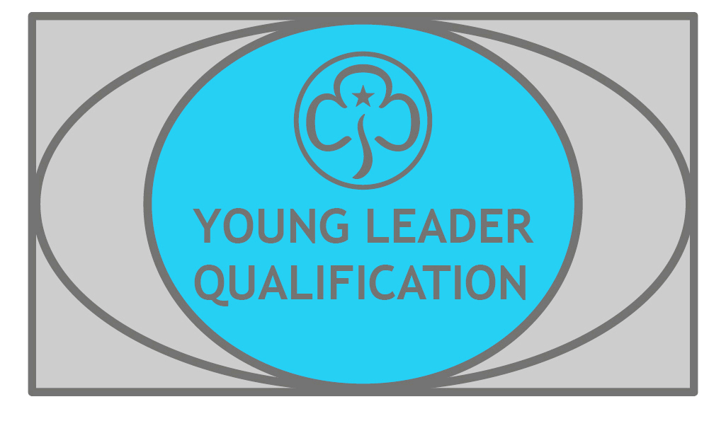
Young Leader Qualification
Congratulations

Young Leaders who completed the YL Qualification 01.01.2022 to 30.06.22
Hannah Berkeley | 2nd Shenley Brownies
Lara Berkeley | 2nd Shenley Brownies
Amelia Bridges | 2nd Shenley Brownies
Eve Burton | 1st Hazlemere Rainbows
Grace Curcher | 1st Winslow Guides
Abigail Hard | 1st Stone Rainbows
Sophie Johnson | 1st Winslow Guides
Fiona Joscelyne | 2nd Buckingham Brownies
Sophie Ridhway | 2nd Shenley Brownies
Emma Swidenbank | 1st Stone Rainbows
Jessica Thorn | 1st Stone Rainbows
Zara Woods | 2nd Bletchley Brownies

